How to book a make-up through our Customer Portal

1. Login to your customer portal.

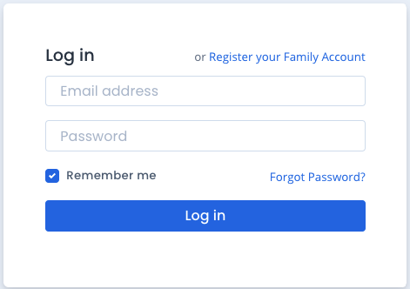

2. Click on the student you wish to book a make-up lesson for.

You can either do this through the side navigation bar, or in the “Students” section at the bottom of the portal home screen.

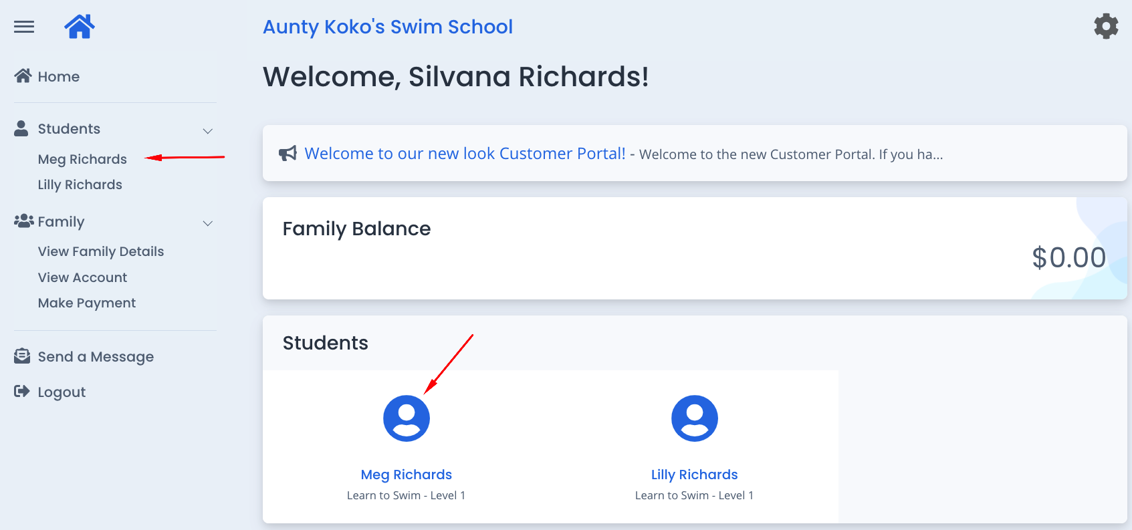

3. The next window will show you the student’s details. In the top section, click on “Book Make-up”.
Please note, this button will only be available if a student has one or more make-up lessons owing. If their make-up balance is 0, you will not be able to book a make-up. The number of make-up lessons available to the student is shown in the top section.

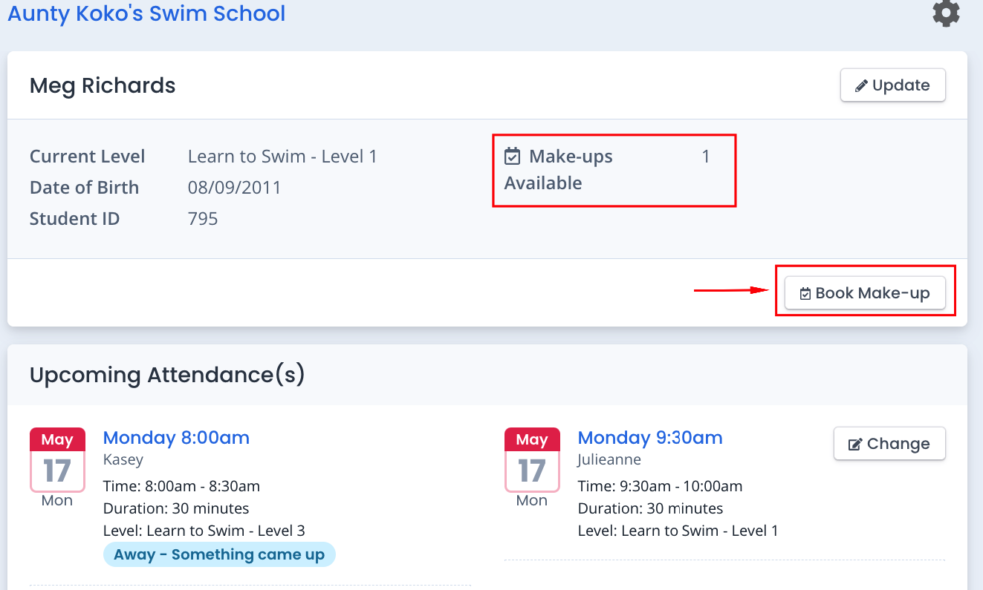

4. You will see a list of make-up lesson spots available. The teacher’s name is in brackets next to the class so you can look through the list to see if your usual teacher is available.
Select the lesson date and time that suits you best and click “Book”.

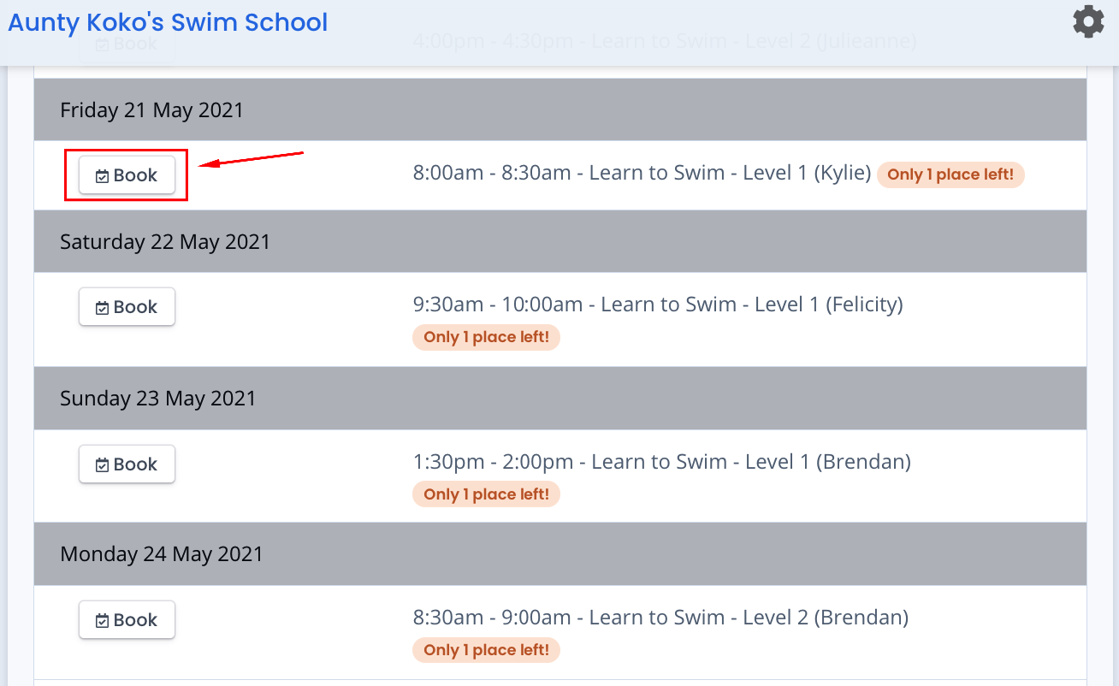

PLEASE NOTE: If no make-up lessons are currently available for your student’s class level, you will see the following message (instead of a list of lesson options to choose from). Vacancies are continuously updated in real time, so keep checking back regularly to see if there are any make-up lesson vacancies available for you.

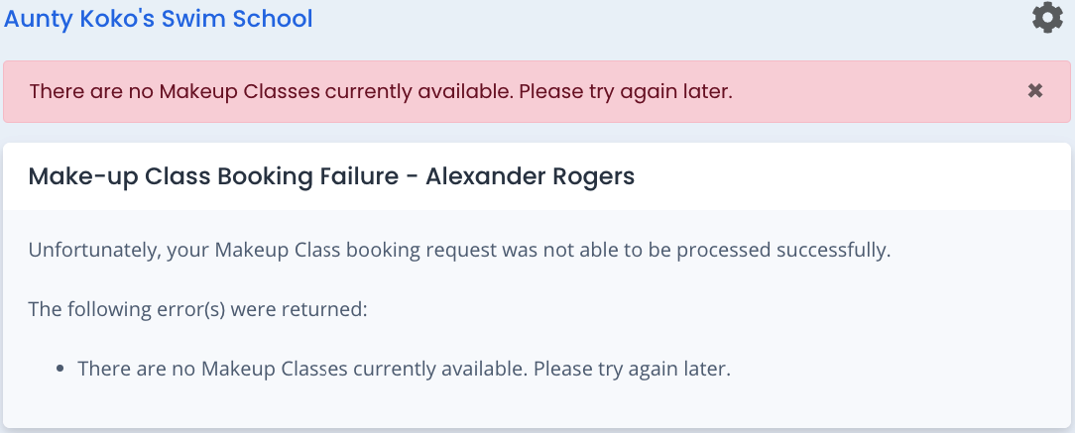

5. Once you have selected a make-up lesson date and time and clicked “book”, this will open a window to review the selected make-up class date and time. You need to tick the “Terms and Conditions” box and click on the “Confirm Booking” button. The make-up lesson will not be booked unless you complete this step. (Note: you will not be able to confirm your booking until you tick the Terms & Conditions” box).

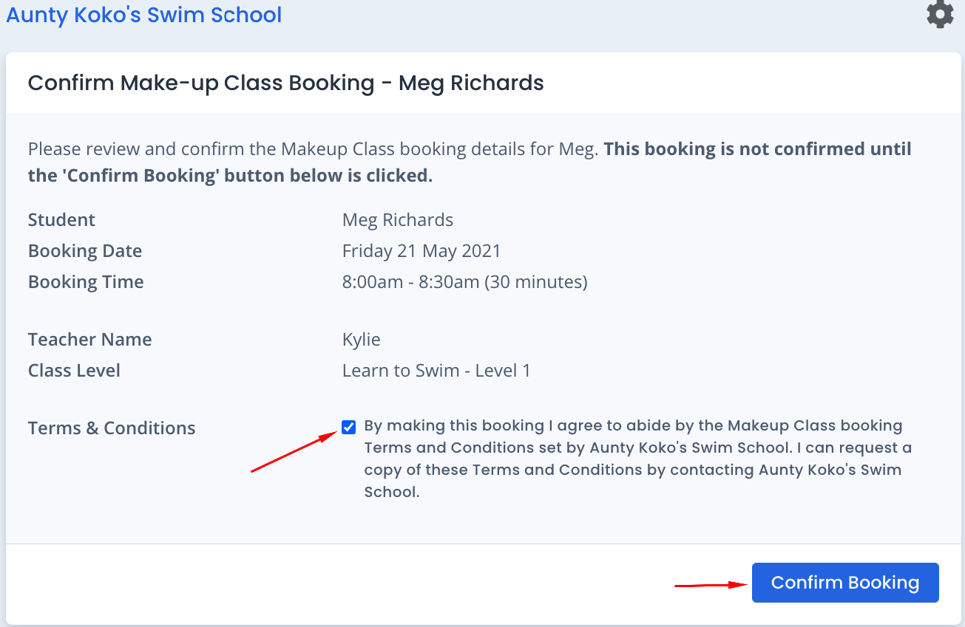

6. Once you click the “Confirm Booking” button, you will receive a confirmation message on the screen, as well as a confirmation email with the lesson details.

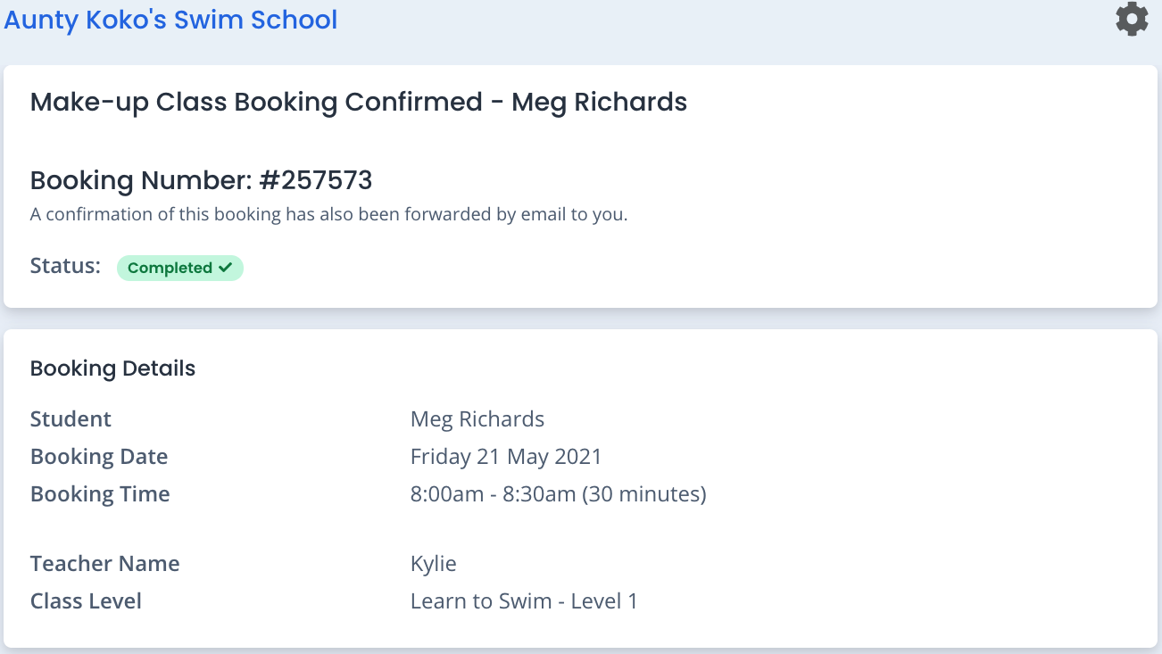

7. If you click on that student again, in their “Upcoming Attendance(s)” you will see their make-up lesson is listed:

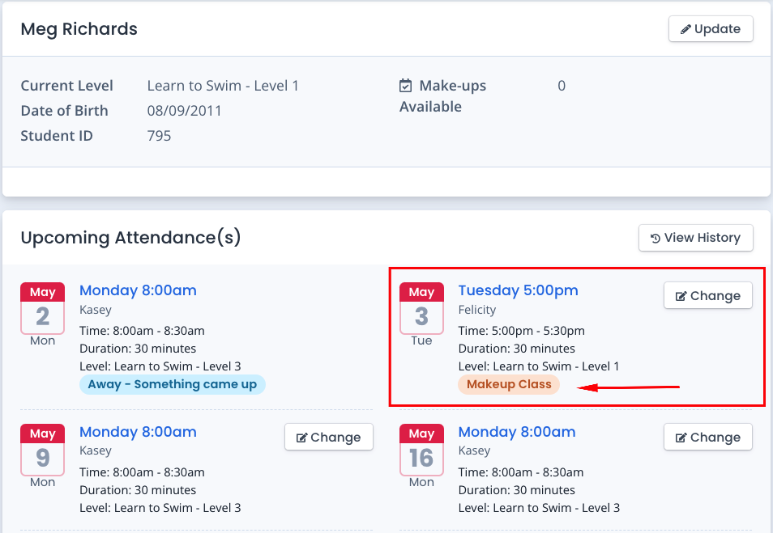

Booking of a make-up lesson is now complete. You do not need to contact the centre, all has been notified and confirmed through the customer portal.

