Customer Portal Overview

Our Customer Portal allows you to do a range of functions such as notifying the centre of an absence, booking a make-up lesson, checking your family account balance, making a payment (if your centre has this option), and updating your contact details.

1. Home screen
Here you can: see your family name; view any Customer Portal messages from your centre; view your family balance; and see your enrolled students. Your navigation tabs are on the left-hand side. Anything blue in the main window is hyperlinked so you can click for quick access to those areas (e.g. on students).

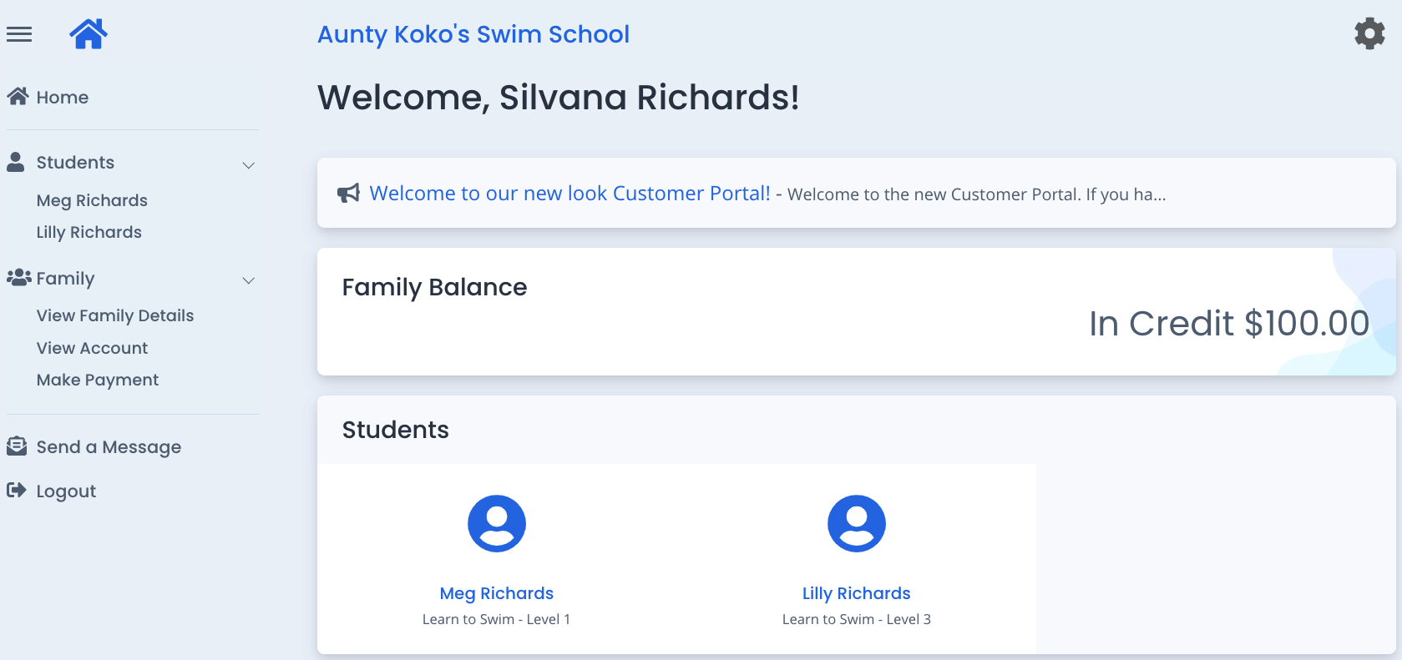

2. Students screen
Click on the student name (either through the navigation bar on the left, or on the student icon on the bottom of the home screen) to view information on current enrolments and upcoming lesson times. It is through the individual student’s screen that you can notify your centre of an absence or book a make-up lesson if you have any owing.

To book a make-up, click “book make-up” (Note: this button will not be available if a student has 0 Make-up lessons available).

To notify an absence, click “Change” on that corresponding lesson.

If you have notified of an absence, this will be shown in your “Upcoming Attendance(s)” section under the lesson date (and the “Change” button will not be visible).

If you have a make-up class booked, this will show in your “Upcoming Attendance(s)” section with “Makeup Class” underneath the lesson.

NOTE: You cannot change an already notified absence. Please contact your centre if you need help with this.

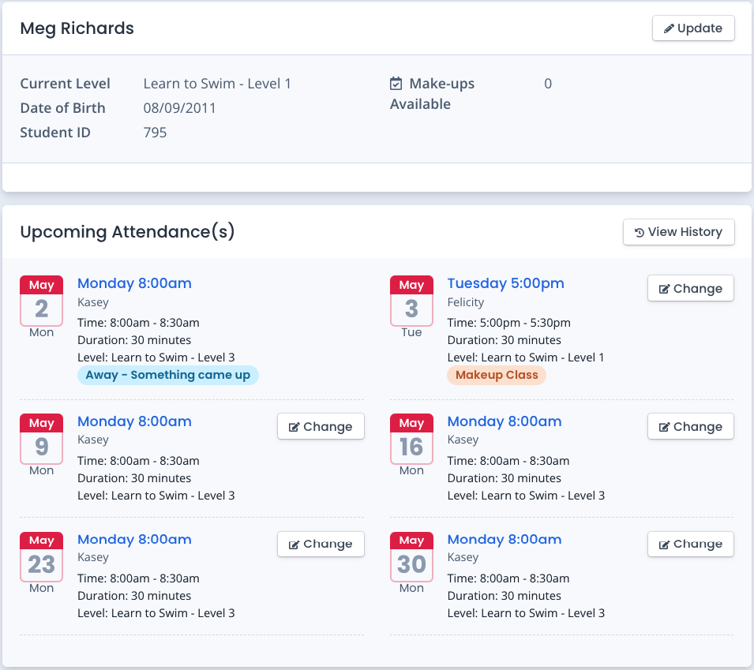

3. View Family Details screen
Here you can view your account information and update your contact details.

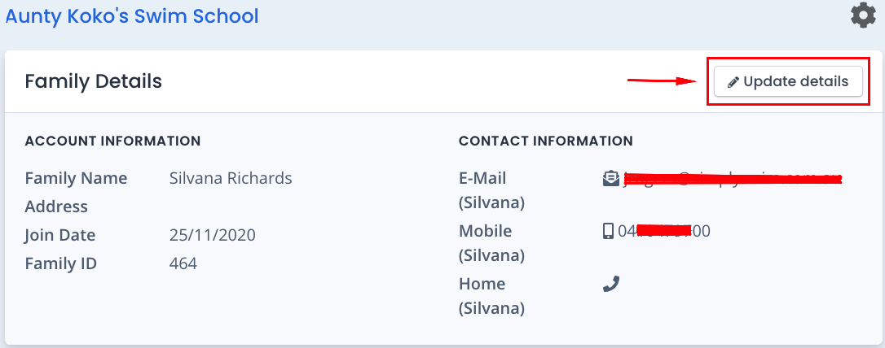

4. View Account screen
Here you can see your family account balance.

If you owe any monies, you will see the following with your family balance and will be able to click “Make a Payment”:

If your account is paid up to date, you will see:

If your family account is in credit, you will see “In Credit” with the dollar amount, for example:

5. Make Payment screen
If your centre accepts online payments, you enter your contact details, credit card details (without any spaces) and payment amount (the amount will default to the current family balance, but you can manually override this by entering the amount you wish to pay), and click the green “Confirm & Pay” button at the bottom of the screen.

6. Send a Message screen
You can send a message directly to your centre through this screen. Enter your subject and message and click “Send”.

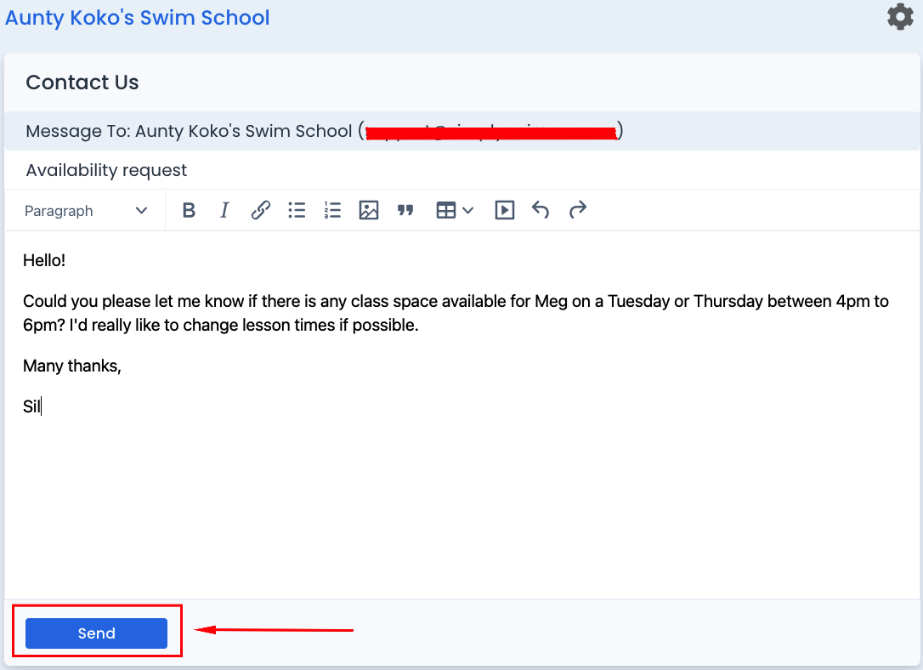

7. Logout
To logout of the portal, you can click “Logout” on the navigation tabs on the left, or click on the cog icon in the top right-hand corner and click “logout”.

