How to notify an absence through our Customer Portal

1. Login to your customer portal.

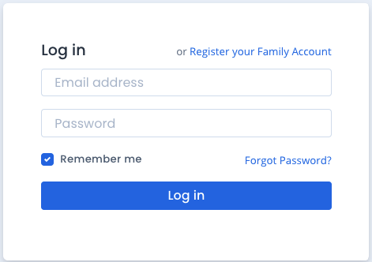

2. Click on the student you wish to notify an absence for. You can either do this through the side navigation bar, or in the “Students” section at the bottom of the portal home screen.

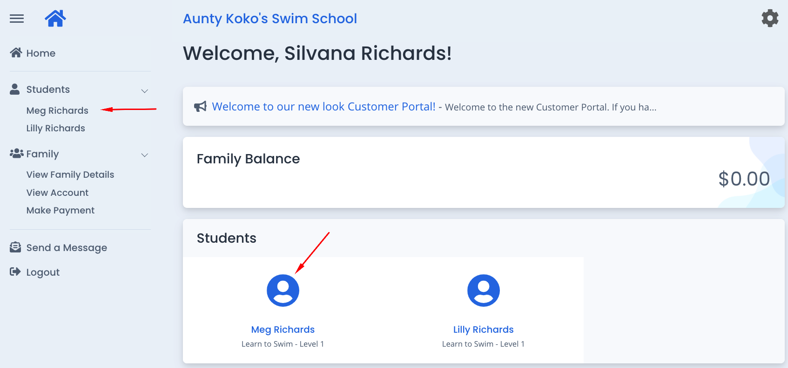

3. In the “Upcoming Attendance(s)” section at the bottom of the screen, find the lesson you wish to notify an absence for and click on “Change” next to that lesson date.

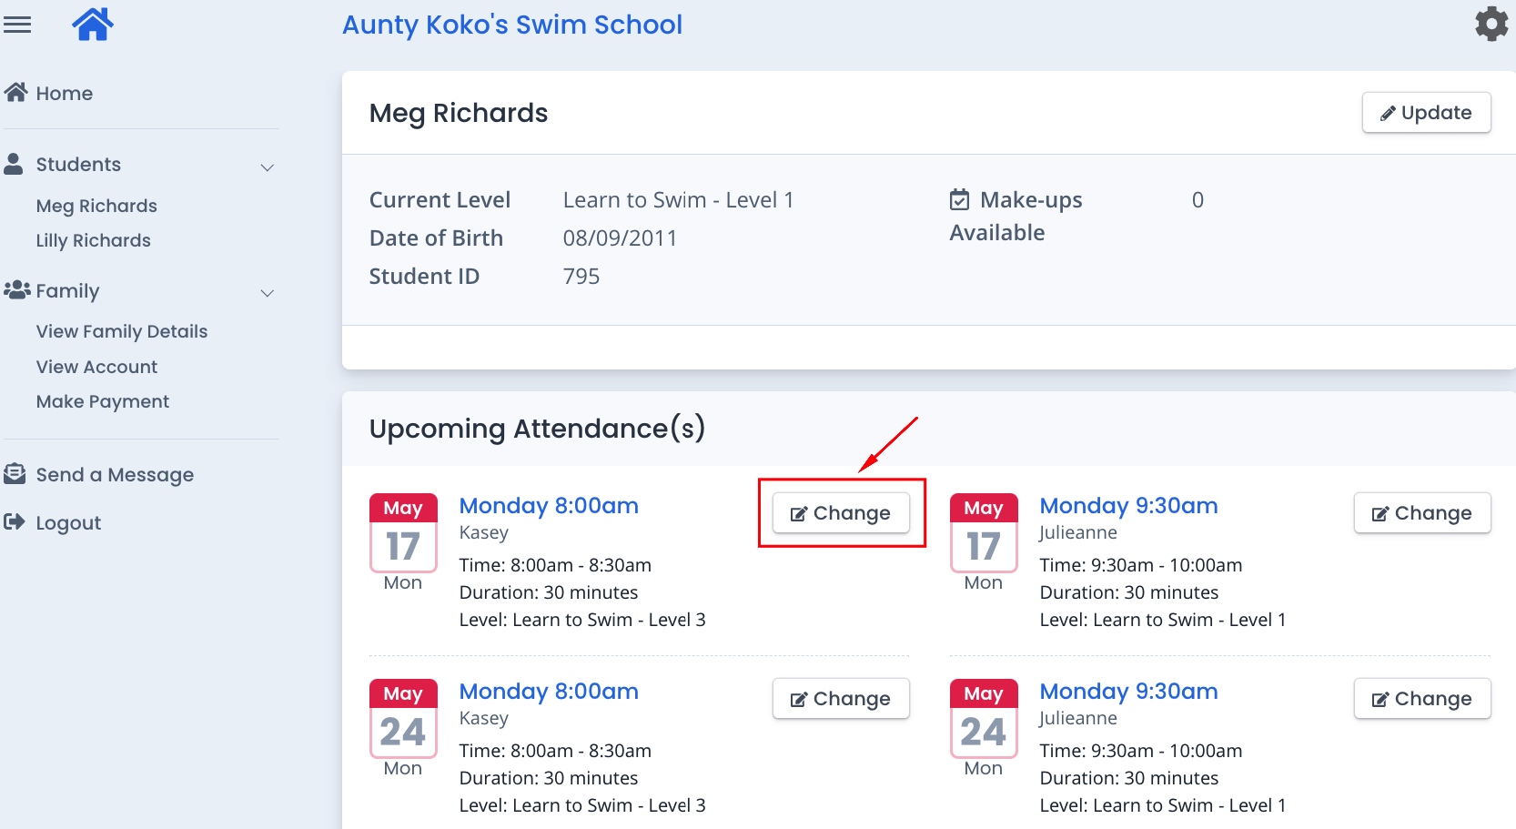

4. Make sure the student, and lesson absence date are correct. Select a reason for the absence from those listed and click “Save”.

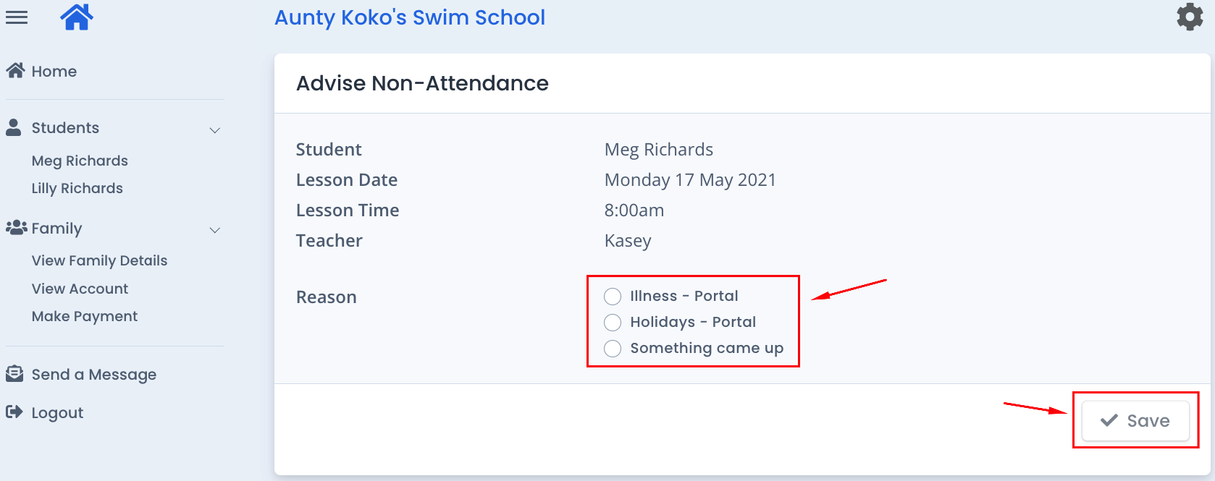

5. This will return you to the student’s screen. In the “Upcoming Attendance(s)” section, you will see that they have been marked as “away” for the selected date with the reason you selected for the absence, and that their make-up balance has now changed (note: make-up lessons are given at the discretion of your centre).

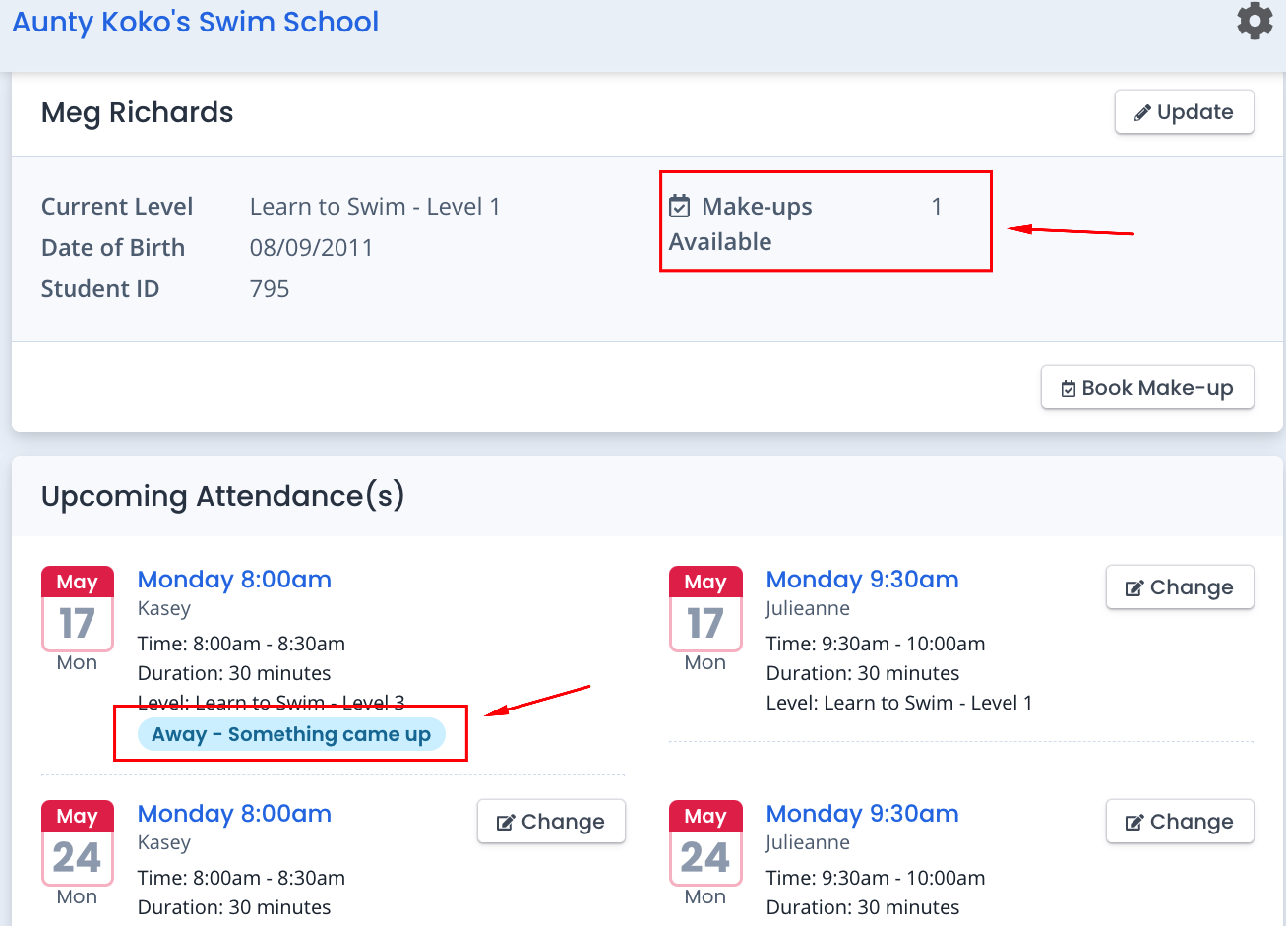

6. If you need to notify another absence for the same student or for a different student, repeat the above steps.

Notification of absence is now complete. You do not need to contact the centre, all has been notified through the customer portal.

