How to register for our Customer Portal

1. Click on the link that was emailed to you.

2. Click on “Register your Family Account”.

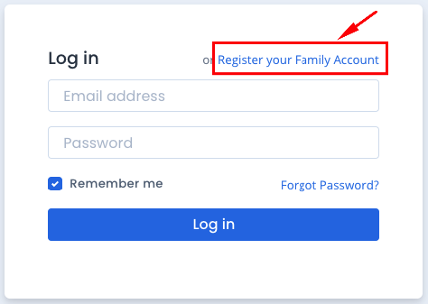

3. Enter your name and email address and click “Register Family Account”.
Note: You need to use the email address that is on file with your centre.

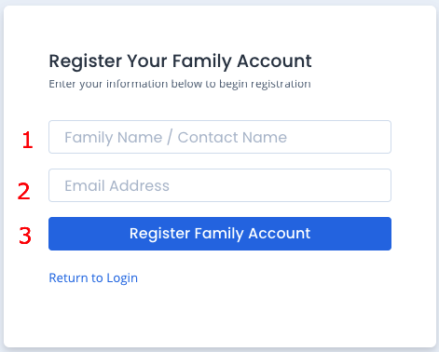

4. Select to receive verification either via email or SMS and click “Verify”.

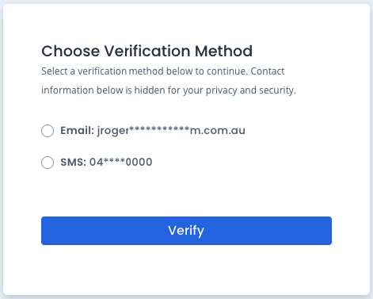

SMS: If you select SMS, you will be sent a verification code via SMS. Enter this into the field and click “Verify”. You will be asked to set a password.

Email: if you select email, you will receive an email to confirm your email address is correct. Click on the “Confirm your email” button, and you will be asked to set your password.

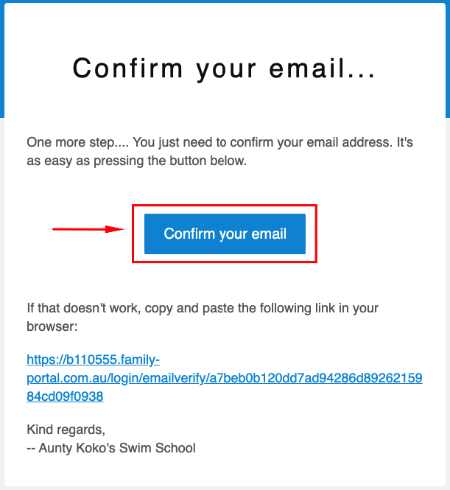

5. Enter and confirm your password and click “Set Password”.

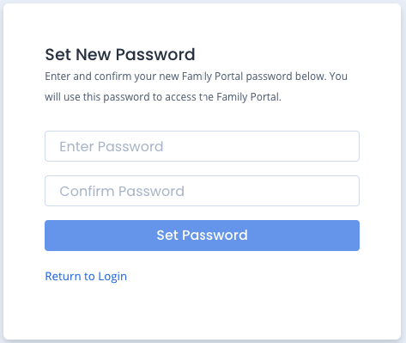

6. Registration is now complete. Click “Return to Login” to access the portal. Login using your email address and password you have created.

